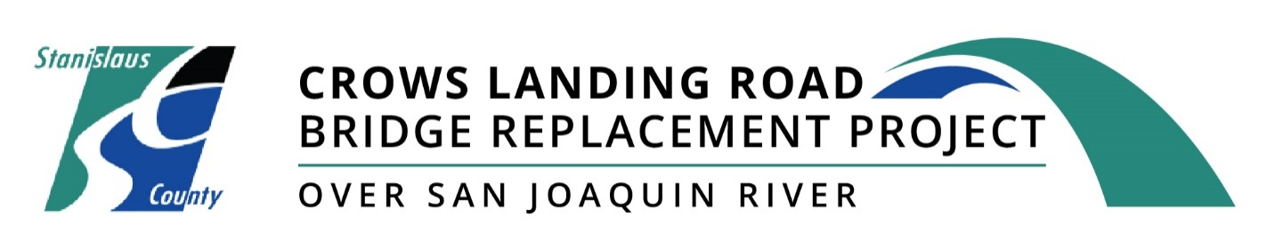
Work activities on the Crows Landing Road Bridge Replacement Project are scheduled to take place on Crows Landing Road between River Road/Marshal Road and South Carpenter Road through September 30, 2023.

Work will take place weekdays generally between Monday through Friday from 6:30 a.m. to 4:30 p.m. The County recommends that motorists use alternative routes whenever possible during construction to avoid delays.

Once completed, project improvements will:
- Improve Safety for Motorists
- Meet Structural & Geometric Standards
- Widen Travel Lanes & Road Shoulders

Construction Stages

To minimize impacts and maintain traffic movement for travelers, construction is being conducted in two stages.

Stage 1 of bridge construction has been successfully completed with the opening of the new bridge and the reopening of Carpenter Road. One lane of traffic in each direction has been routed onto the new bridge.

Stage 2 of construction officially kicked off in July 2022. This includes the demolition of the existing bridge, widening the new structure to accommodate a third traffic lane on the north side of the new bridge, and roadway resurfacing work before the bridge opens.

Once completed, the new bridge will feature wider travel lanes and road shoulders to improve safety for motorists. It will also meet Caltrans and American Association of State Highway and Transportation Officials’ structural and geometric standards.

The bridge will be completed with full width for traffic in Spring 2023.

In Summer 2023, the removal of temporary trestle (support framework) over San Joaquin River will complete the project.

What to Expect

October-November 2022
Construction crews continue demolition of the old Crows Landing Bridge and begin construction of the foundation of the new bridge.

This work includes:
- Removal of the old bridge substructure and foundation over the San Joaquin River.
- Building Stage 2 foundation (columns and abutments) for construction of the east side of the new bridge.

December 2022-January 2023
During the months of December and January, crews will continue construction of the north side of the new bridge.

This work includes:
- Erecting falsework (temporary support structures) to prepare for new concrete to be poured.
- Forming exterior girder (support beams) to support the structure prior to new concrete being poured.

February 2023
In February 2023, crews will carry out the deck drainage portion of Stage 2 construction and install rebar (reinforcement steel) onto the new bridge.

Additional work includes:
- Pouring the concrete deck for the new bridge.
- Begin installing barriers and railings on the new structure.

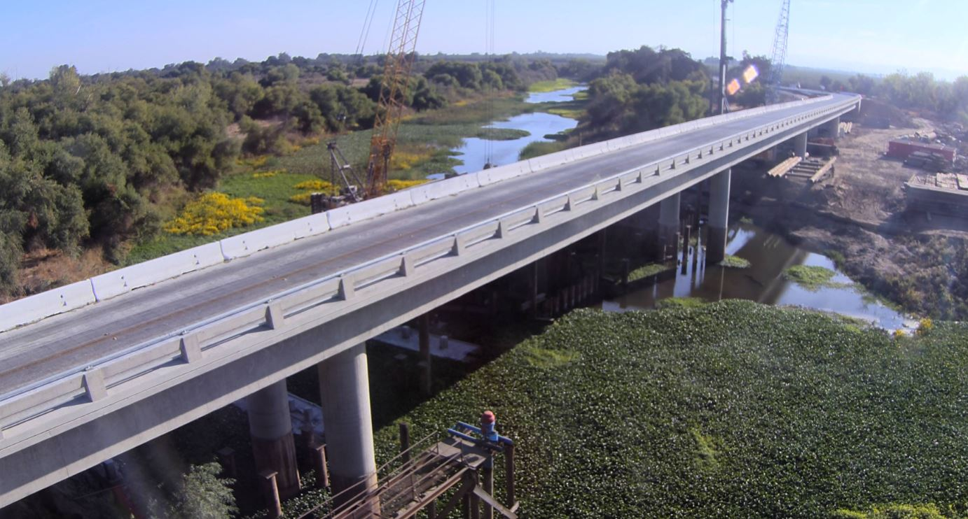
Photo of the new bridge structure looking south.

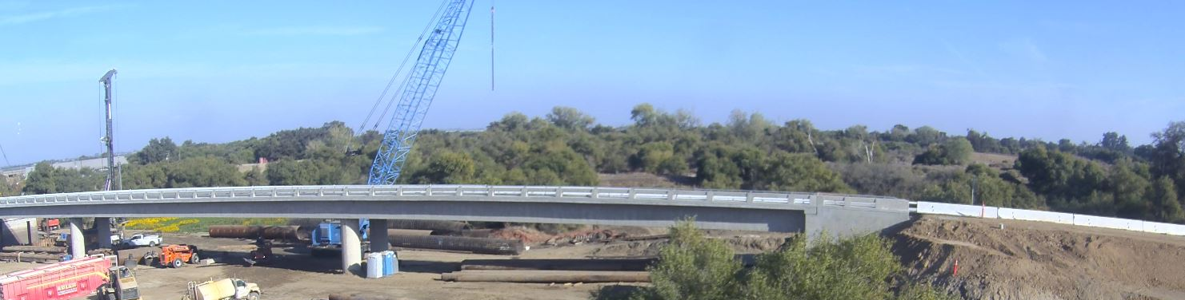
Photo of the new bridge structure looking from the north side of the new bridge.

Construction Safety Moment – If You See Something, Say Something!

For the safety of the general public, construction sites should be accessed by authorized construction personnel only. Crossing safety barriers, not obeying safety signage, or trespassing onto a construction site can be very dangerous. If you see suspicious behavior, please call our project hotline at (209) 683-5071 or email us at info@crowslandingbridge.com.

Keep your community safe by:
- Staying out of construction sites
- Obeying construction signage and flaggers
- Taking detours when necessary
- Driving safely and obeying reduced speed limits on roadways in construction zones

We appreciate your cooperation!

Potential Impacts

During construction, access to local property owners will be maintained and potential road closure near properties will be coordinated on an individual basis. In addition, public safety access will be maintained at all times throughout construction. Local property owners and the traveling public may experience:

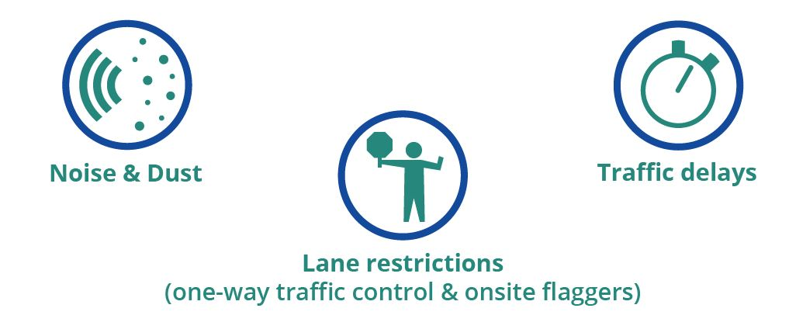
Stay Updated
We apologize for the traffic impacts this work may cause and thank you in advance for your patience. For more information or to sign-up for electronic updates, visit crowslandingbridge.com, email info@crowslandingbridge.com or call the project information line at (209) 683-5071.
Please help us spread the word and share this information with your friends, neighbors, colleagues, constituents and on your social media pages. If you would like to be removed from the project’s database, please respond with the word ‘Remove’ in the subject line. Thank you!

